User manual for sending music

- Music has to be send on mail music @linum.hr
- Receiving mail will be checked 2 at a day.
- Deadline for sending music is 07.04.2025
- Music has to be with this name xxxx_aaaaaaaaaaa.mp3, where
  - xxxx – it is id number of your competitor
  - aaaaa – it is a name of competitor
  - mp3 – mandatory extension
- Good example of file name
  - 1229_MIRON Irina.mp3
  - 1196_MARCHIS Rais.mp3
- Wrong example of file name
  - MIRON Irina.mp3
  - 1229.mp3
  - 1229_ MIRON Irina.mp3
  - 1229_MIRON Irina
- To find a correct ID number of your competitor please check it on this link in registration SW
- 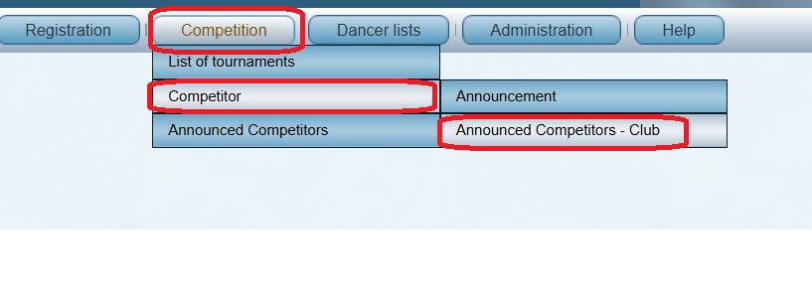
- All mail will be collected by Linum Team and deliver to music on competition
- Linum Team will not check the quality of music material, and from this reason please have it a backup copy on data stick, and bring it to competition
- When you send a music, you will receive automatic reply. Please ro not answer on this automatic reply mail

